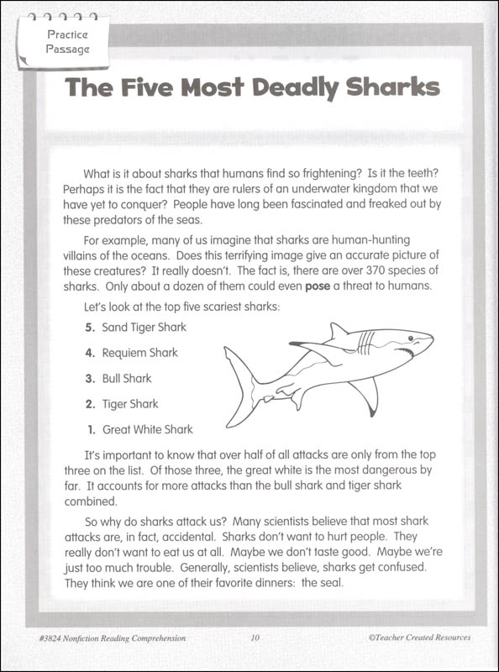Practice reading this passage for the week. Underline the words that are difficult for you as well as the errors you make and practice them until you can read the passage with no errors.